1.
plugins {
id 'java'
}

group 'org.example'
version '1.0-SNAPSHOT'

sourceCompatibility = 1.8
println "Hello World"
repositories {
maven {
url 'https://repo1.maven.org/maven2/'
}
}

dependencies {
testCompile group: 'junit', name: 'junit', version: '4.12'
compile 'com.google.code.gson:gson:2.8.0'
}
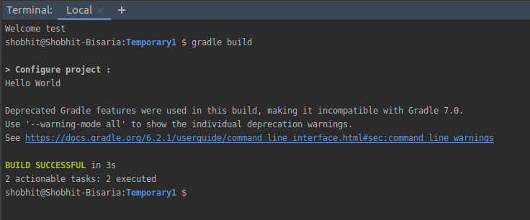

2.
apply plugin : 'java'

sourceSets{
main{
java.srcDirs = ['src']
}
}
jar {
manifest {
attributes 'Main-Class': 'Hello'
}
}
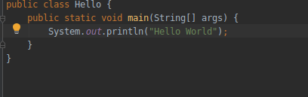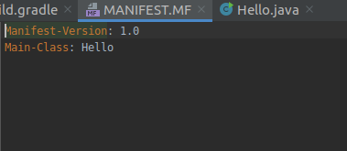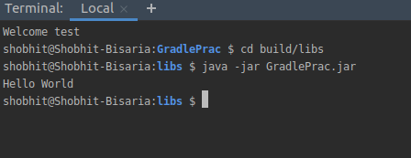

3.
a)compile

This is where you should declare dependencies which are required at compile time, but should not leak into the runtime. Compile is the group of dependencies you need to build your application.

b)runtime

This is where you should declare dependencies which are only required at runtime, and not at compile time.
c)testcompile

This is where you should declare dependencies which are required at test compile time, but should not leak into the runtime. TestCompile is a group of dependencies that you need only for testing

d)testruntime

This is where you should declare dependencies which are only required at test runtime, and not at test compile time.apply plugin : 'java'

group 'org.example'
version '1.0-SNAPSHOT'

sourceCompatibility = 1.8

println "Hello World"
repositories {
maven {
url 'https://repo1.maven.org/maven2/'
}
}

dependencies {
testCompile group: 'junit', name: 'junit', version: '4.12'
compile 'com.google.code.gson:gson:2.8.0'
runtime group: 'org.springframework', name: 'spring-core', version: '2.5'
}

4.
apply plugin : 'java'

group 'org.example'
version '1.0-SNAPSHOT'

sourceCompatibility = 1.8

jar {
manifest {
attributes 'Main-Class': 'Hello'
}
}

println "Hello World"
repositories {
maven {
url 'https://repo1.maven.org/maven2/'
}
}

dependencies {
testCompile group: 'junit', name: 'junit', version: '4.12'
compile 'com.google.code.gson:gson:2.8.0'
}

class GreetingPlugin implements Plugin<Project> {
void apply(Project project) {
project.task('hello') {
doLast {
println new Date()
}
}
}
}

apply plugin: GreetingPlugin
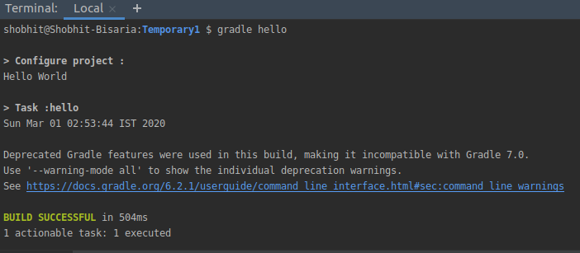

5.

6.
apply plugin : 'java'

sourceSets{
main{
java.srcDirs = ['src/main/javaCode1']
}
}
jar {
manifest {
attributes 'Main-Class': 'Hello'
}
}
println "Hello World"
dependencies{
/*// https://mvnrepository.com/artifact/com.google.code.gson/gson
compile group: 'com.google.code.gson', name: 'gson', version: '2.8.6'*/
runtimeOnly group: 'org.springframework', name: 'spring-core', version: '2.5'
}

class GreetingPlugin implements Plugin<Project> {
void apply(Project project) {
project.task('hello') {
doLast {
println new Date()
}
}
}
}
// Apply the plugin
apply plugin: GreetingPlugin

repositories{
mavenCentral()
}
./gradlew wrapper --gradle-version 6.2.1 hello

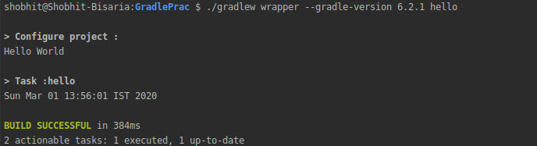

7.
Gradle build --profile

